SUMMERVILLE CREDIT UNION · CONSOLIDATED MEMBER GUIDE · CSUM-09 of 30
Transaction History

Module: nFinia Digital Banking > Move Money > Transaction History
Sources: Summerville Reports Series A (36 docs) + Series B (25 docs) | Features: nFinia Documentation Features Spreadsheet
01 STEP-BY-STEP GUIDE

Navigation: Dashboard > Move Money > Transaction History

Step 1 — Start from Dashboard
After authentication, the member lands on the Dashboard, which surfaces real-time account balances, the Quick Transfer widget, and upcoming payment obligations in a single consolidated view. To review Instant Pay transfer activity, the member selects Move Money from the top navigation bar.
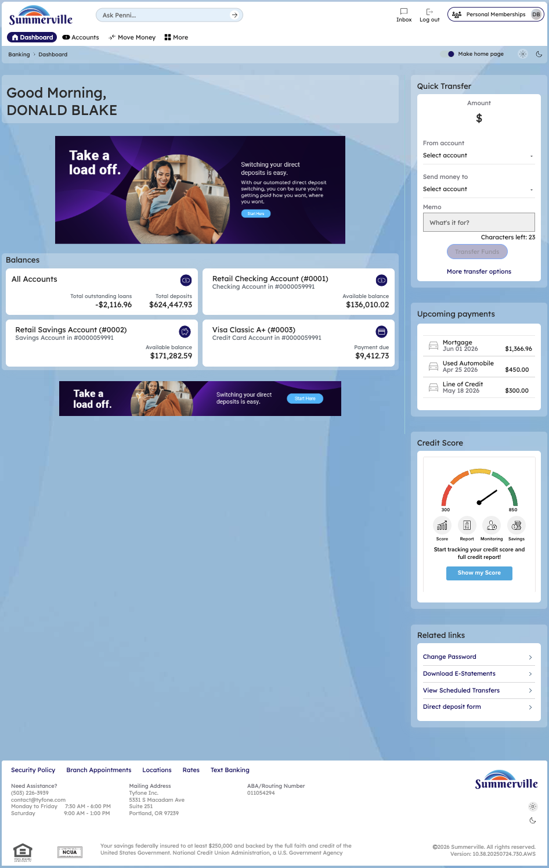
Step 1: Start from the Dashboard

Step 2 — Navigate to Move Money Hub
The Move Money Hub consolidates all payment and transfer workflows into a tile-based screen organised under Pay and Transfers categories. The member selects the Transaction History tile to access transfer history.
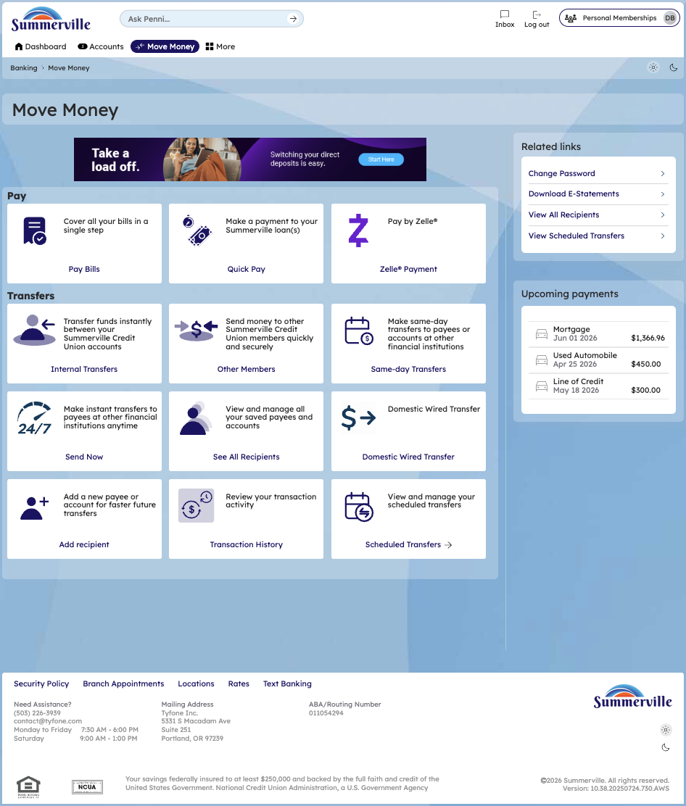
Step 2: Move Money Hub

Step 3 — Review Transaction History
With Transfer Type set to Instant Pay, the Scheduled Transfers screen surfaces the full FedNow transaction history for the member — each entry showing the recipient, source account, destination institution, transaction ID, amount, status, and failure reason where applicable. This view allows members to quickly identify and investigate failed Instant Pay transactions, such as those that timed out during processing at the receiving institution.
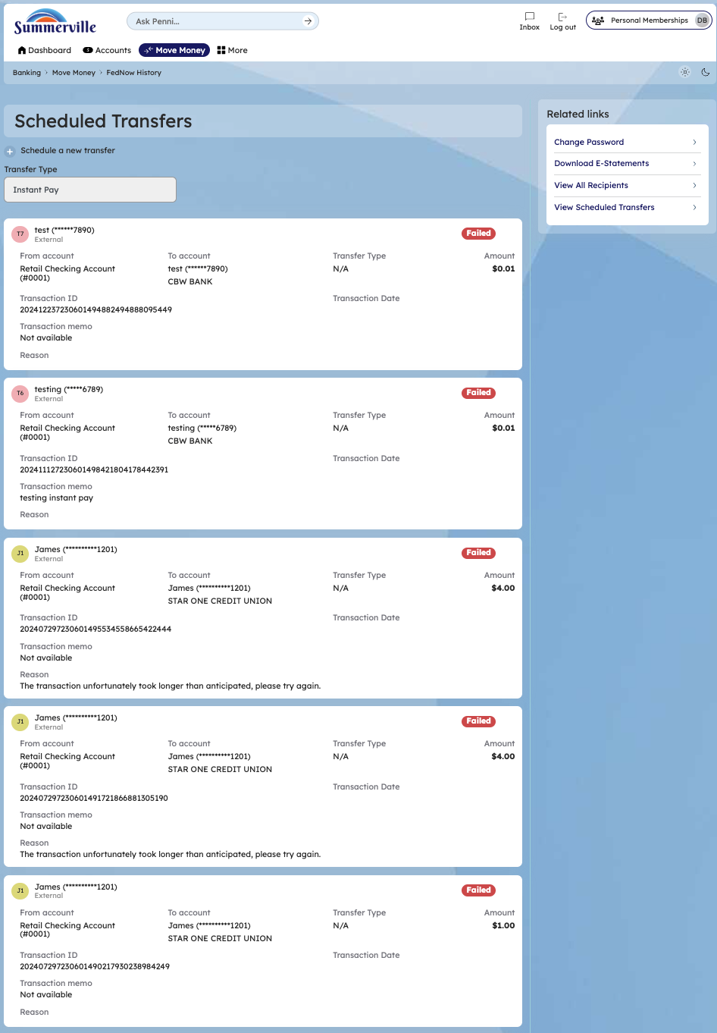
Step 3: Scheduled Transfers — Instant Pay history (FedNow)

